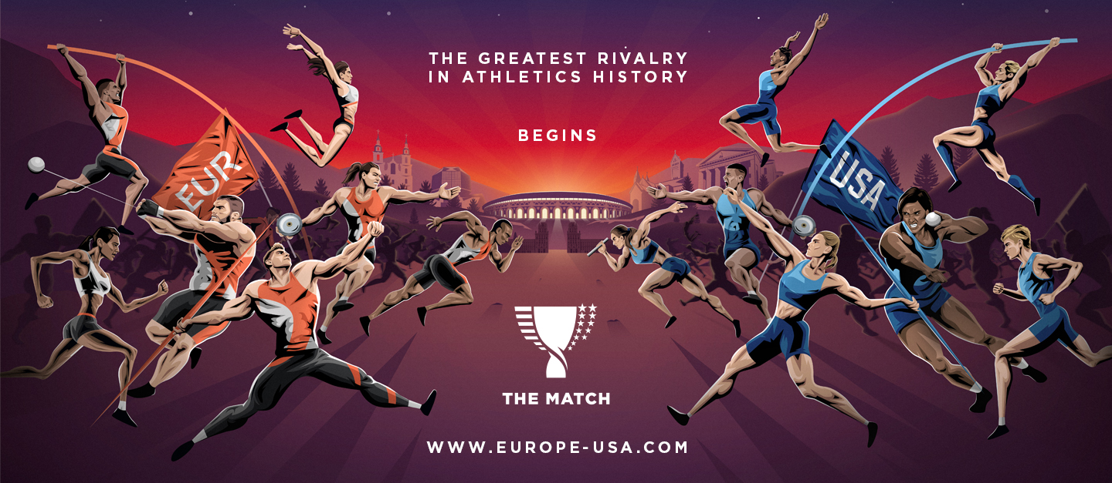
Dear colleagues!
We would happily like to inform you that on 9-10 September 2019 Minsk will host The Match Europe v USA.
The best European and American athletes will clash in an outdoor meeting for the first time in athletics history! The head-to-head Ryder Cup-style competition will take place in the recently renovated Dinamo National Olympic Stadium. Belarus will be the host of this great battle, which will bring together some of the best athletes in the world on the eve of the IAAF World Championships. Over 25,000 spectators, 300 tremendous athletes, everything will come together for this sporting spectacular in the very heart of the capital of Belarus.
Tickets are already on sale!
The local organizing committee will be grateful if you place the official poster or other materials (please see attached) of The Match and the official link (http://europe-usa.com/) on your website and spread the information about The Match to attract as many athletics fans as possible.
For more information, please contact Maryia Badzich (Belarus Athletic Federation Vice-President) badzich@bfla.eu or visit our social media pages:

WEBSITE FACEBOOK INSTAGRAM

